Project Management Professionals Notes

**Contents**

Introduction 2

Eligibility 2

Application Process 2

Examination Domains 4

Project, Project Managements and Organizational Influences 6

What is Project 6

Relationships between Portfolio, Program and Project Management 6

Project need and strategic planning 7

Project Management Office 8

What is Project Management 8

Organization Types 9

Organizational Governance 11

Organizational Process Assets 11

Enterprise Environmental Factors 12

Project Initiation (13%) 13

Integration Management 13

Develop Project Charter 14

Stakeholder Management 17

Identify Stakeholders 17

# Introduction

## Eligibility

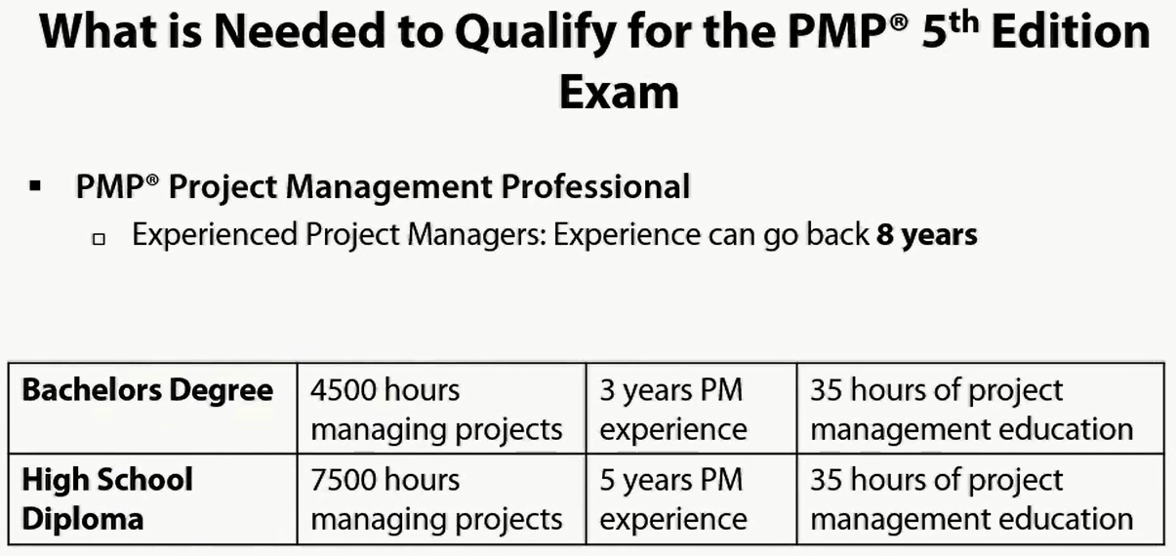

## Application Process

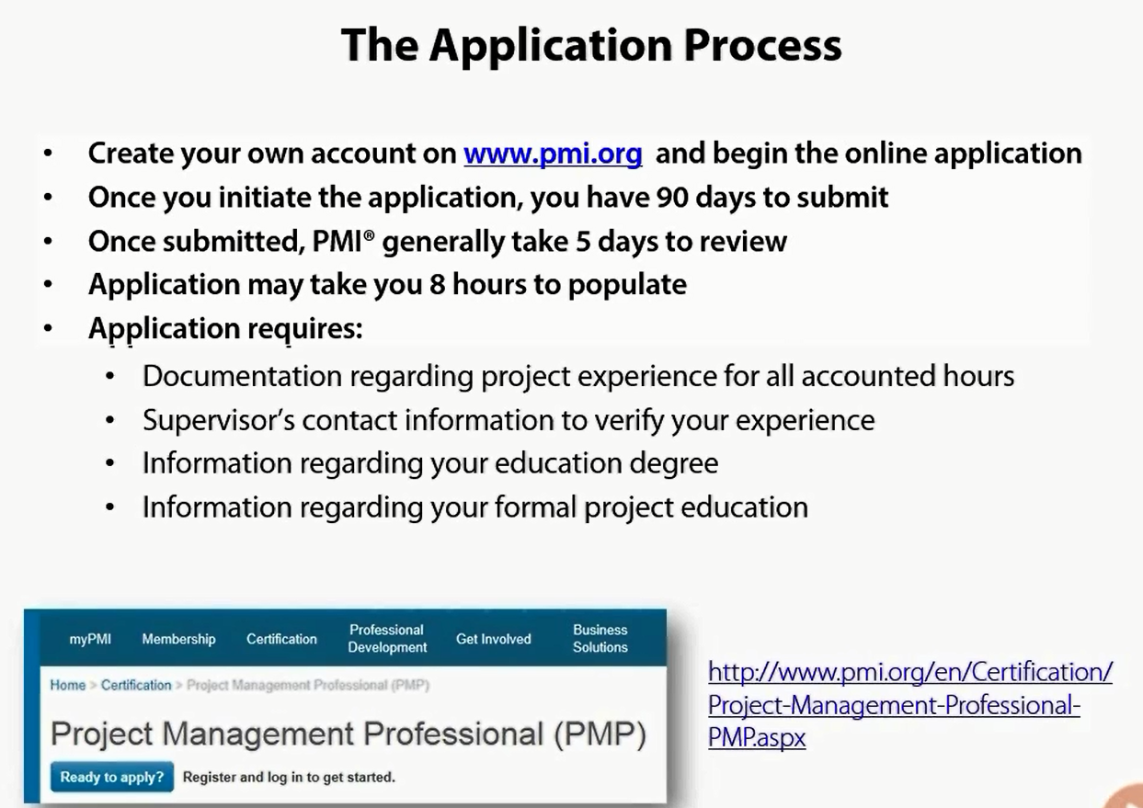

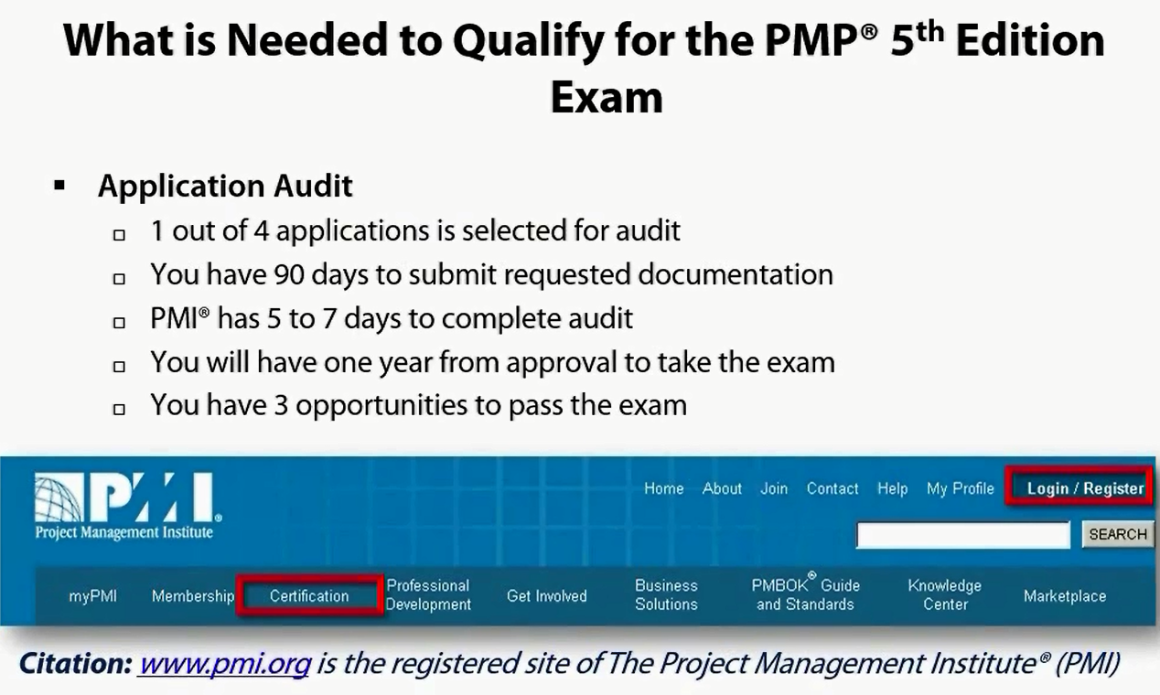

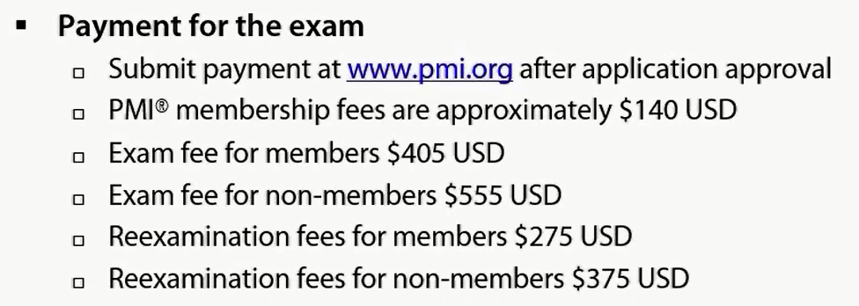

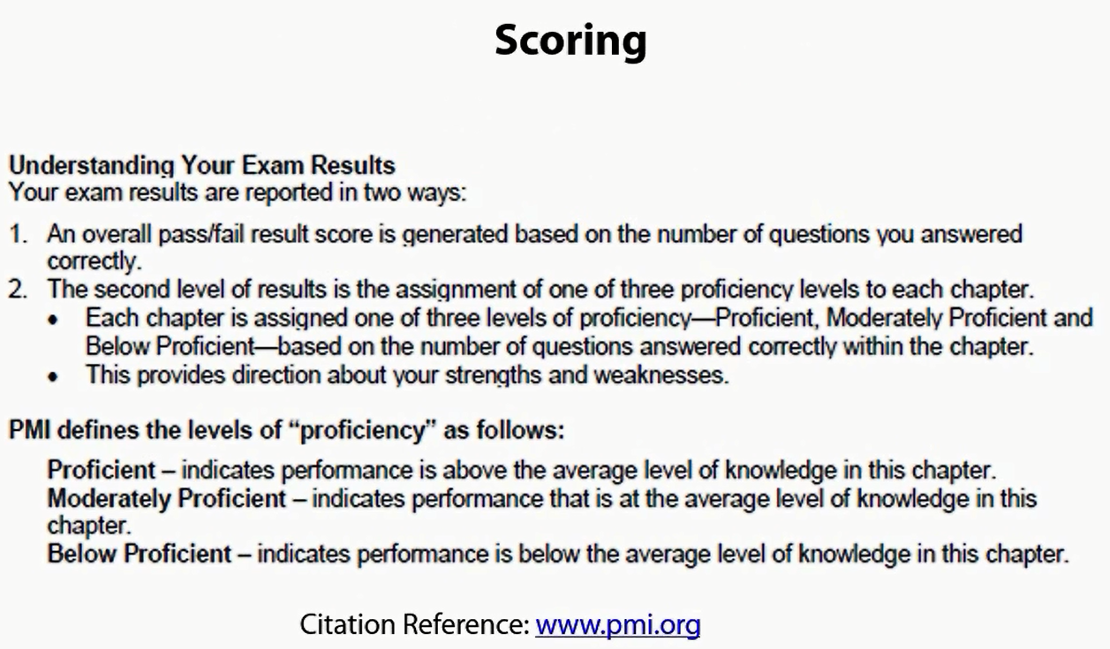

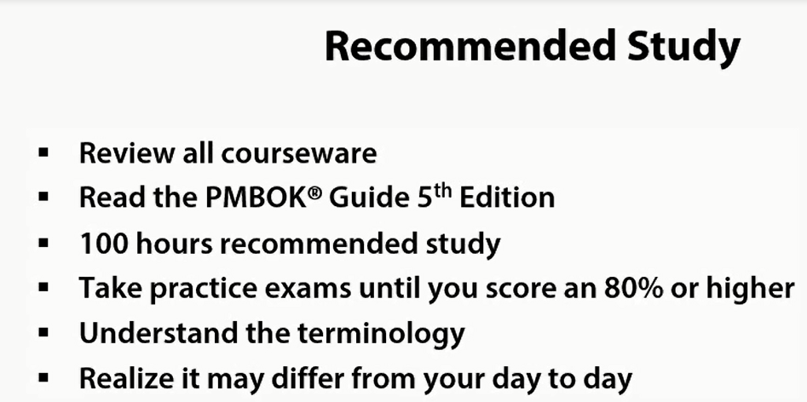

## Examination Domains

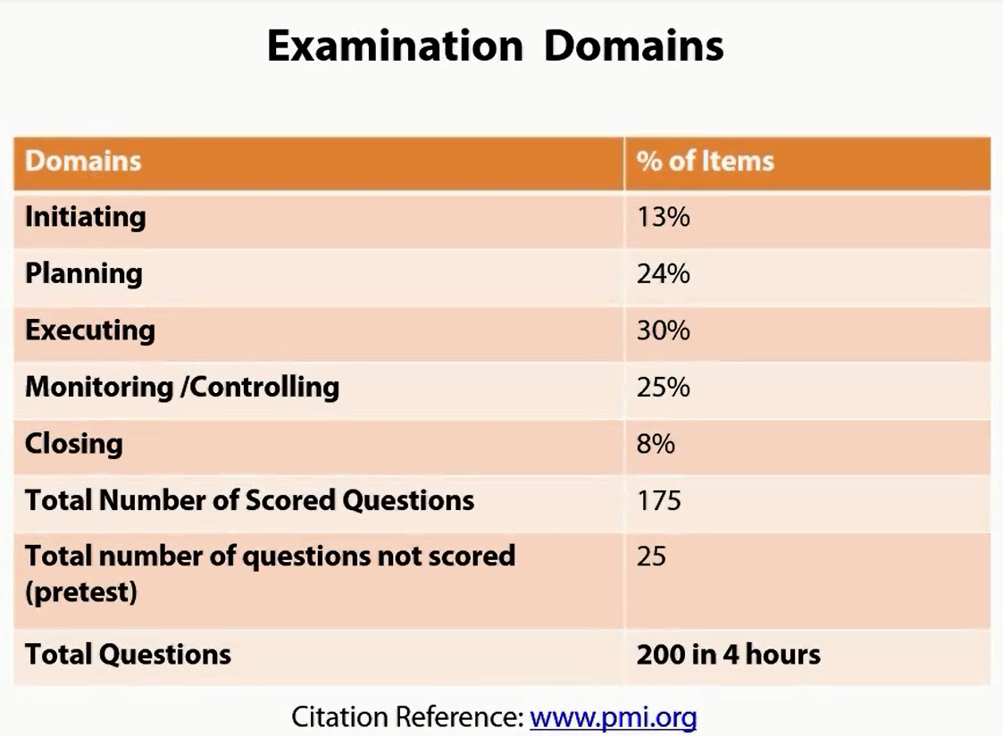

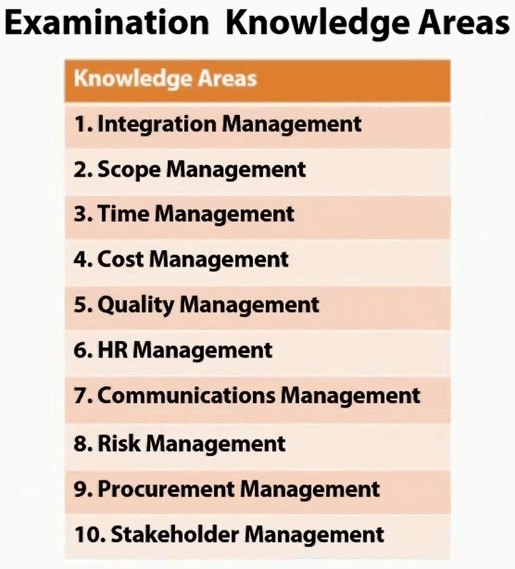

**I S T C Q H C R P S**

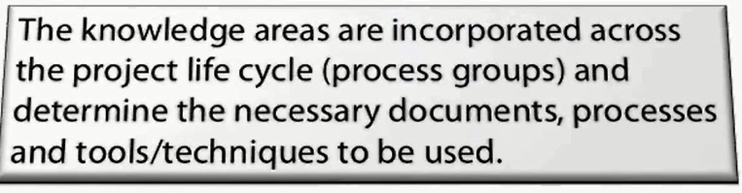

# Project, Project Managements and Organizational Influences

## What is Project

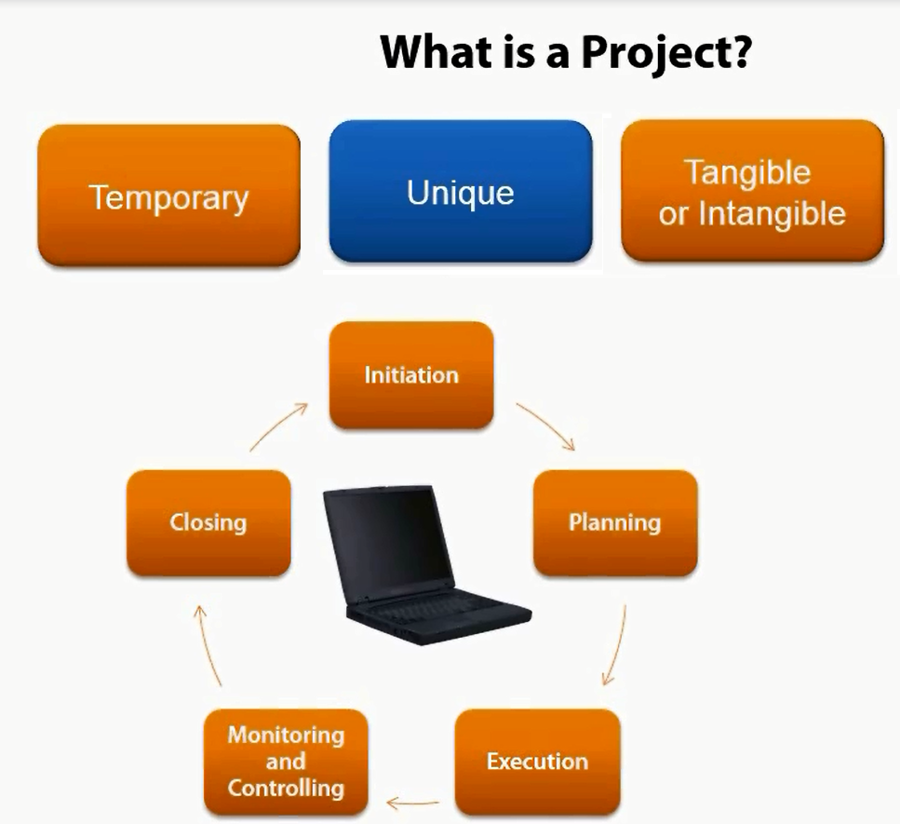

## Relationships between Portfolio, Program and Project Management

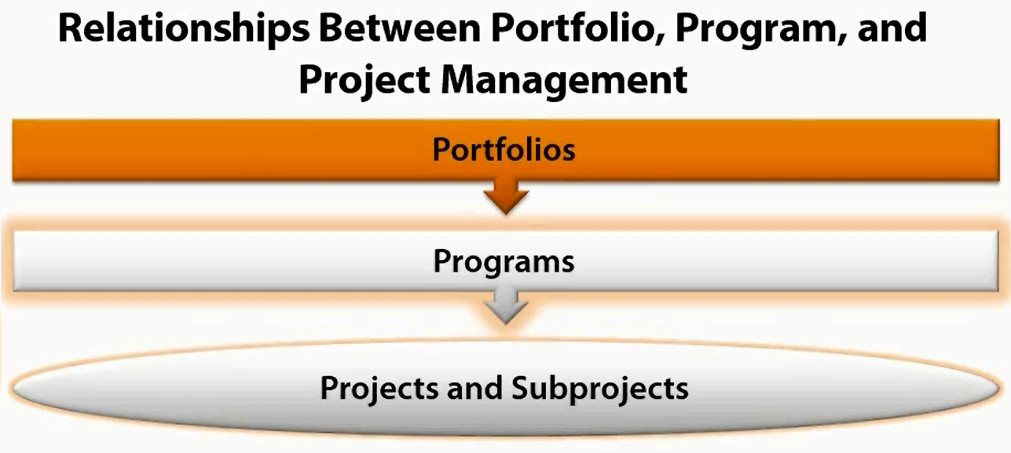

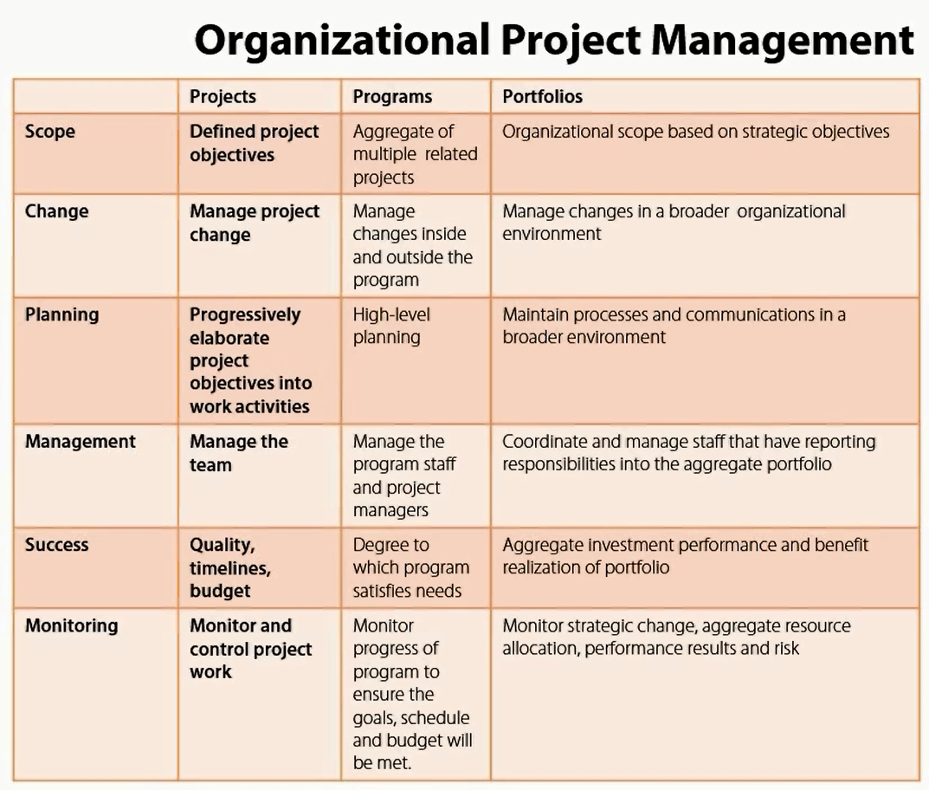

## Project need and strategic planning

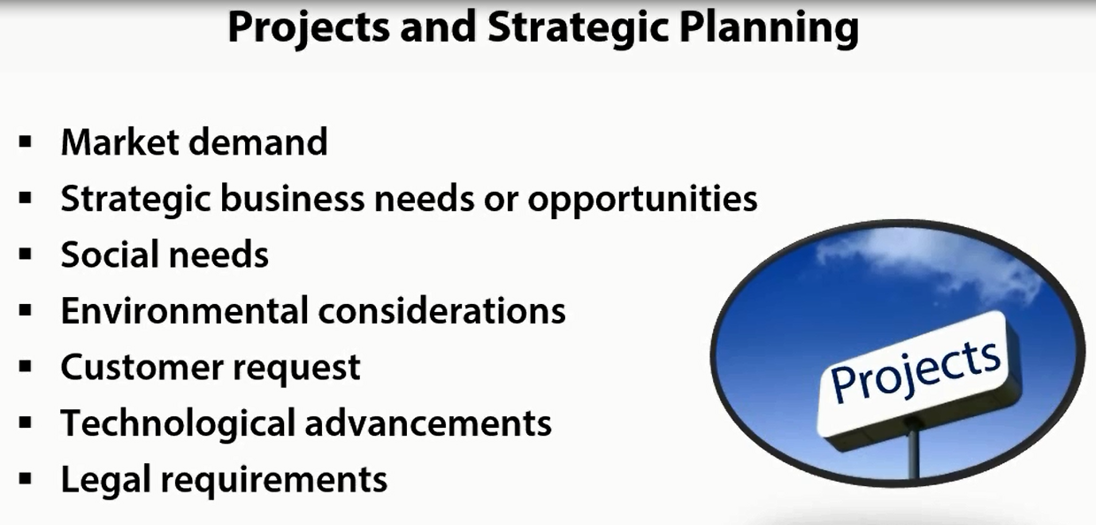

## Project Management Office

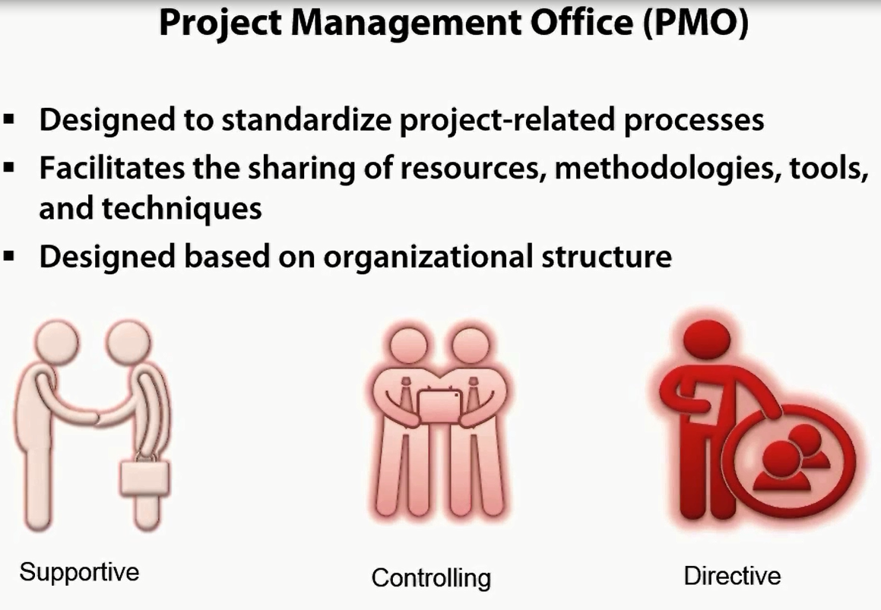

**Exam assumes you have a PMO**

## What is Project Management

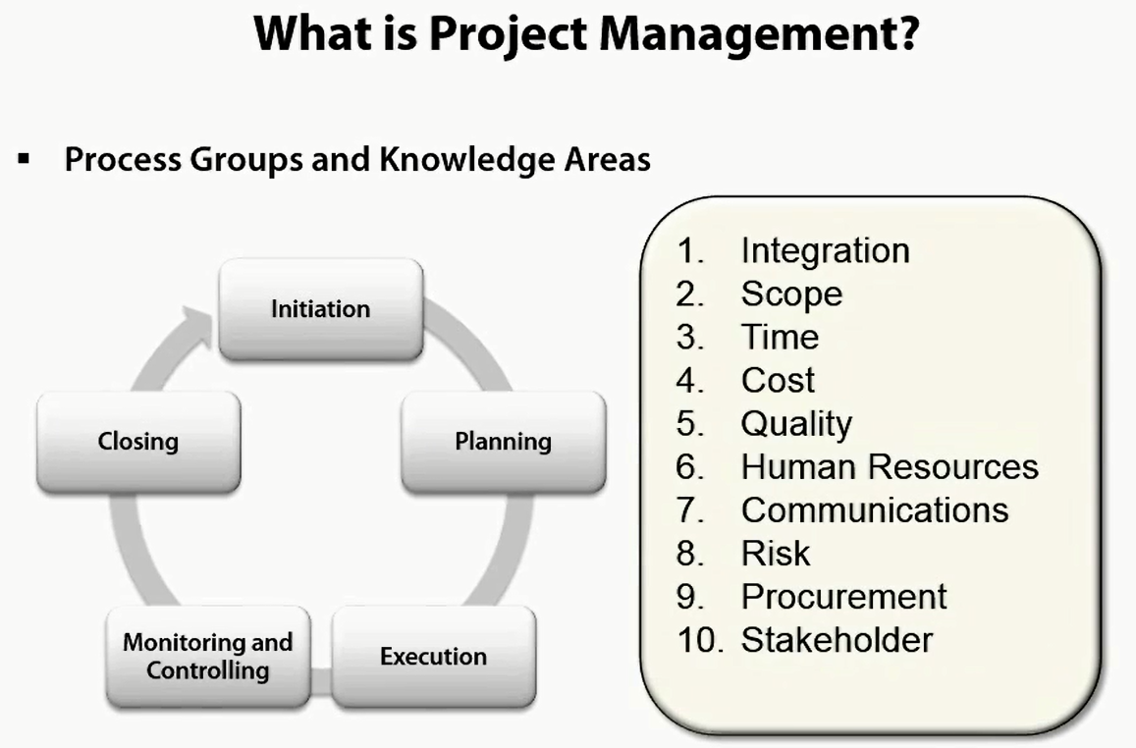

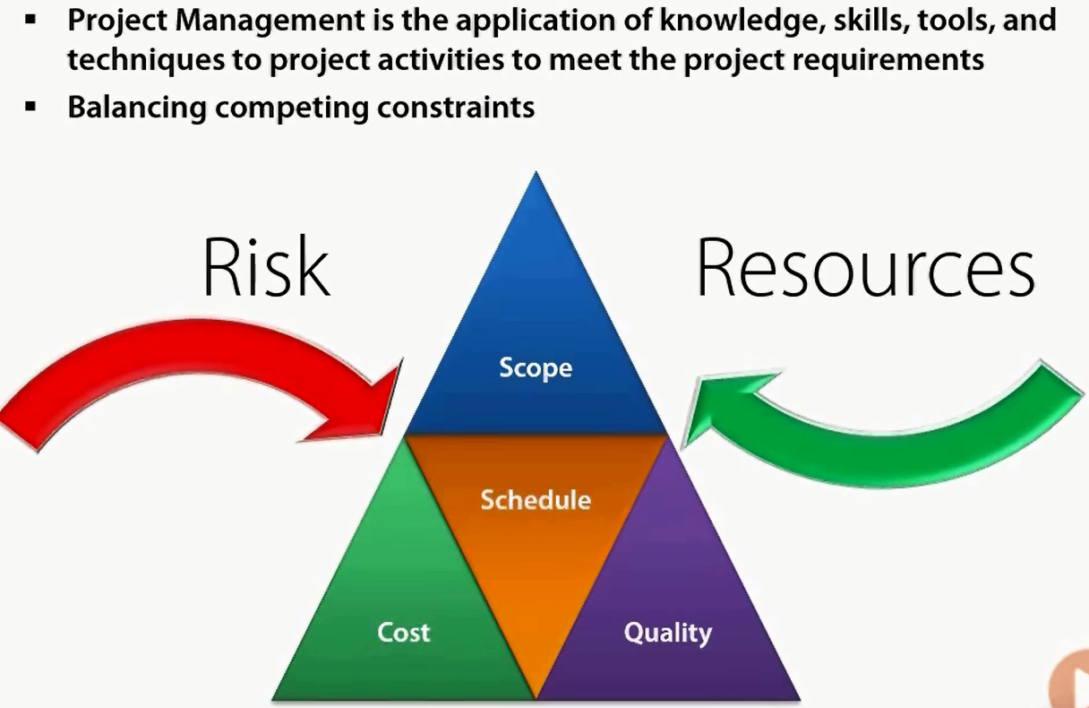

## Organization Types

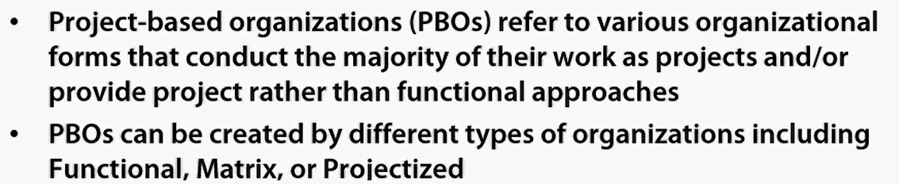

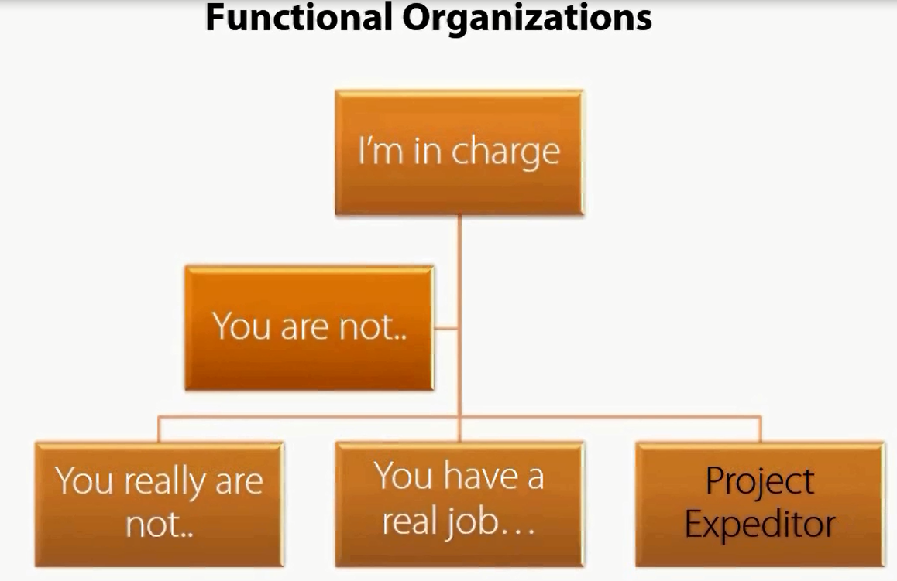

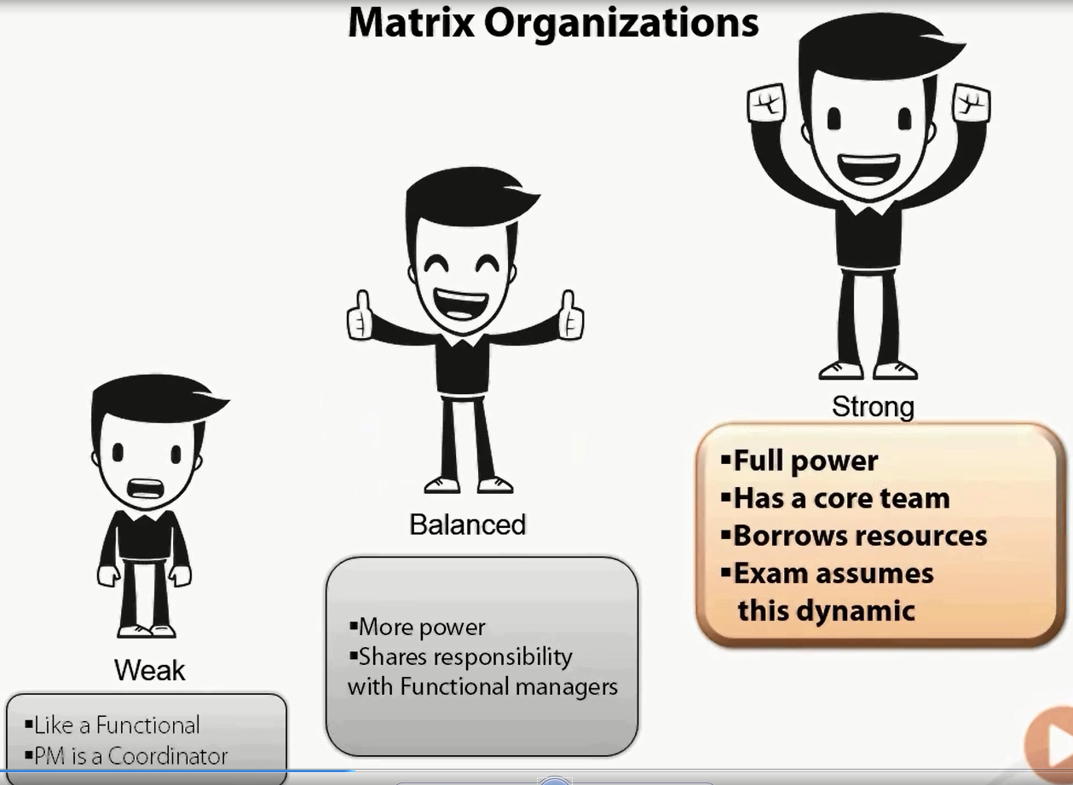

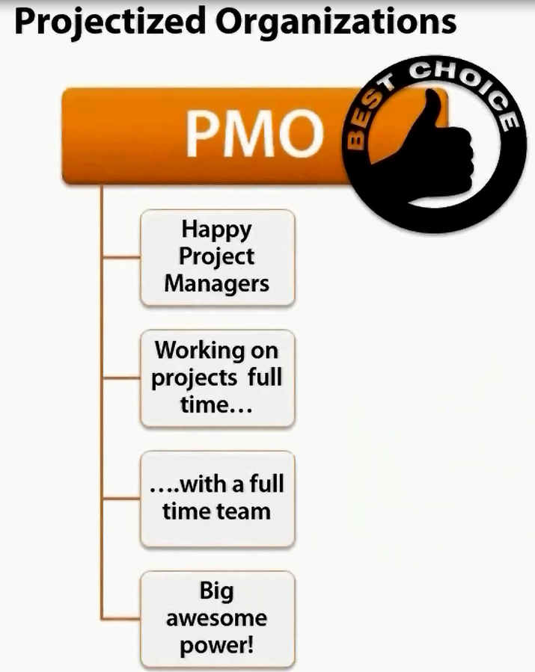

## Organizational Governance

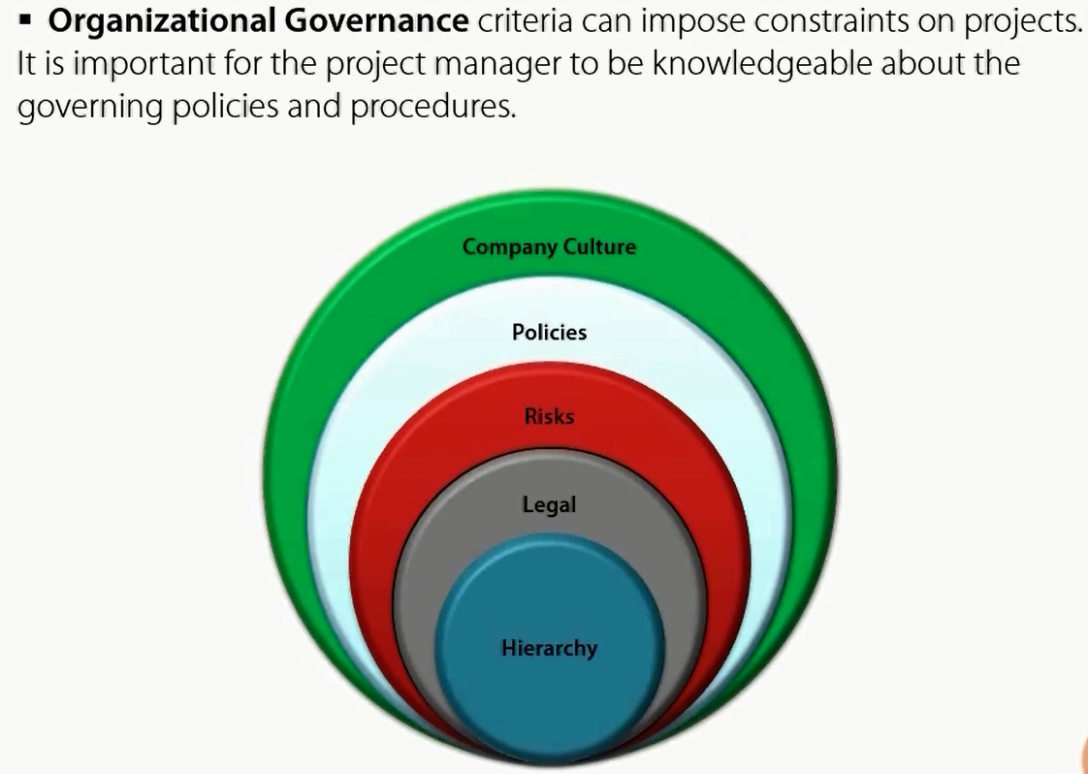

## Organizational Process Assets

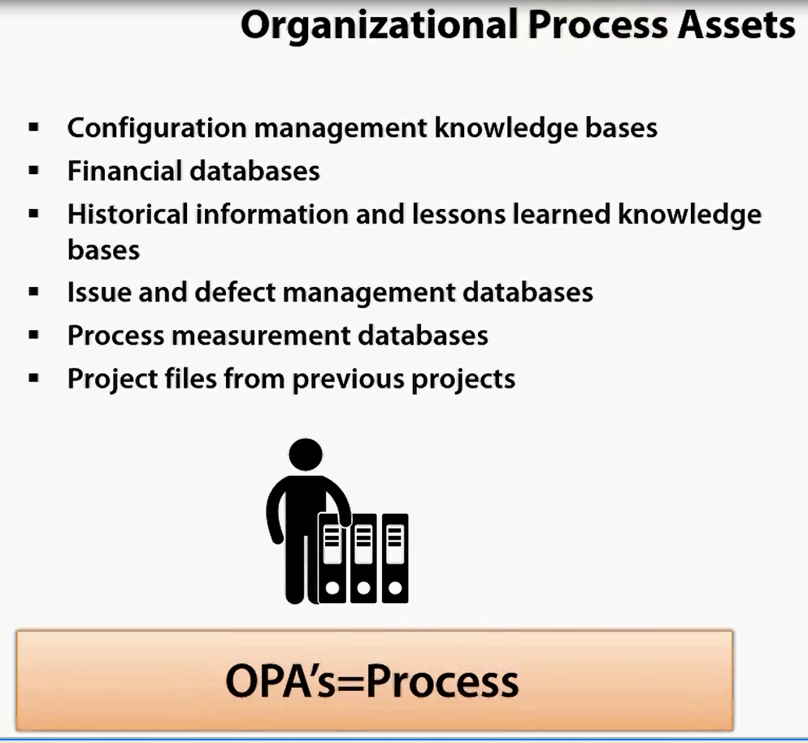

## Enterprise Environmental Factors

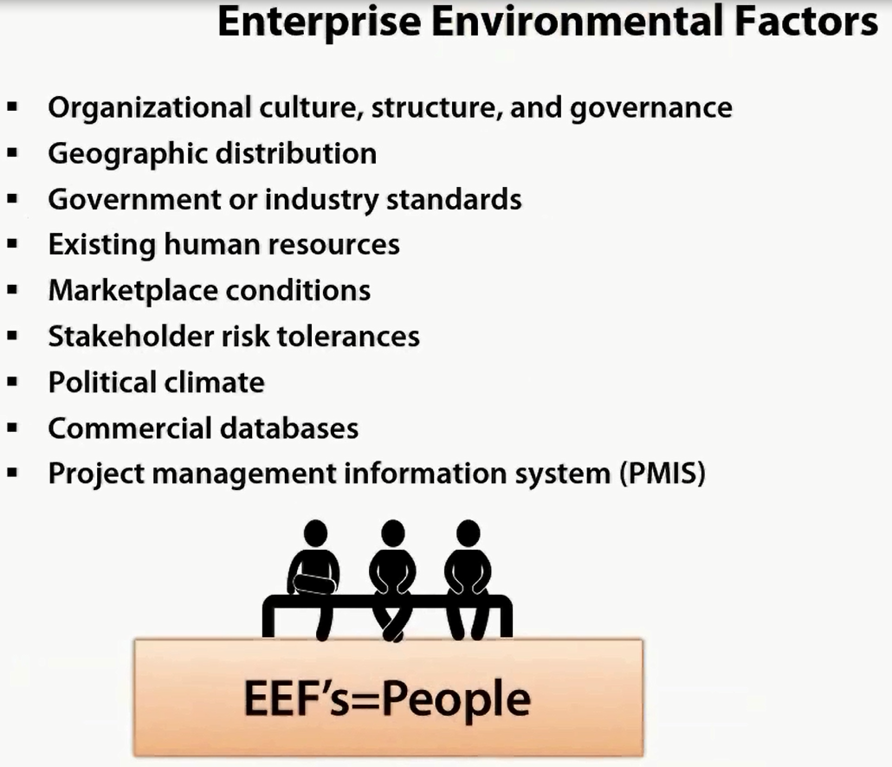

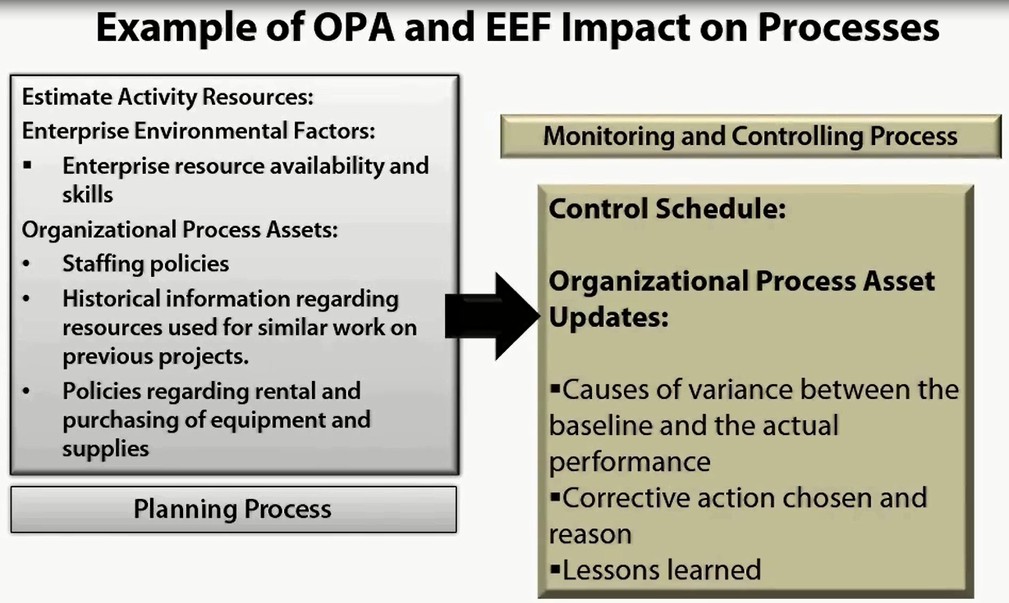

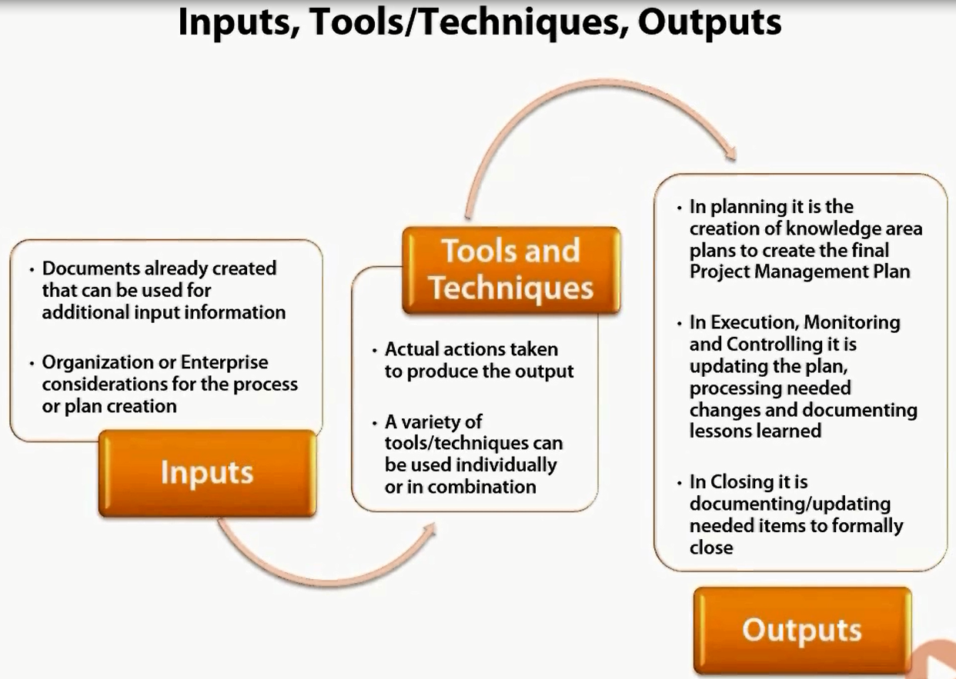

# Project Initiation (13%)

## Integration Management

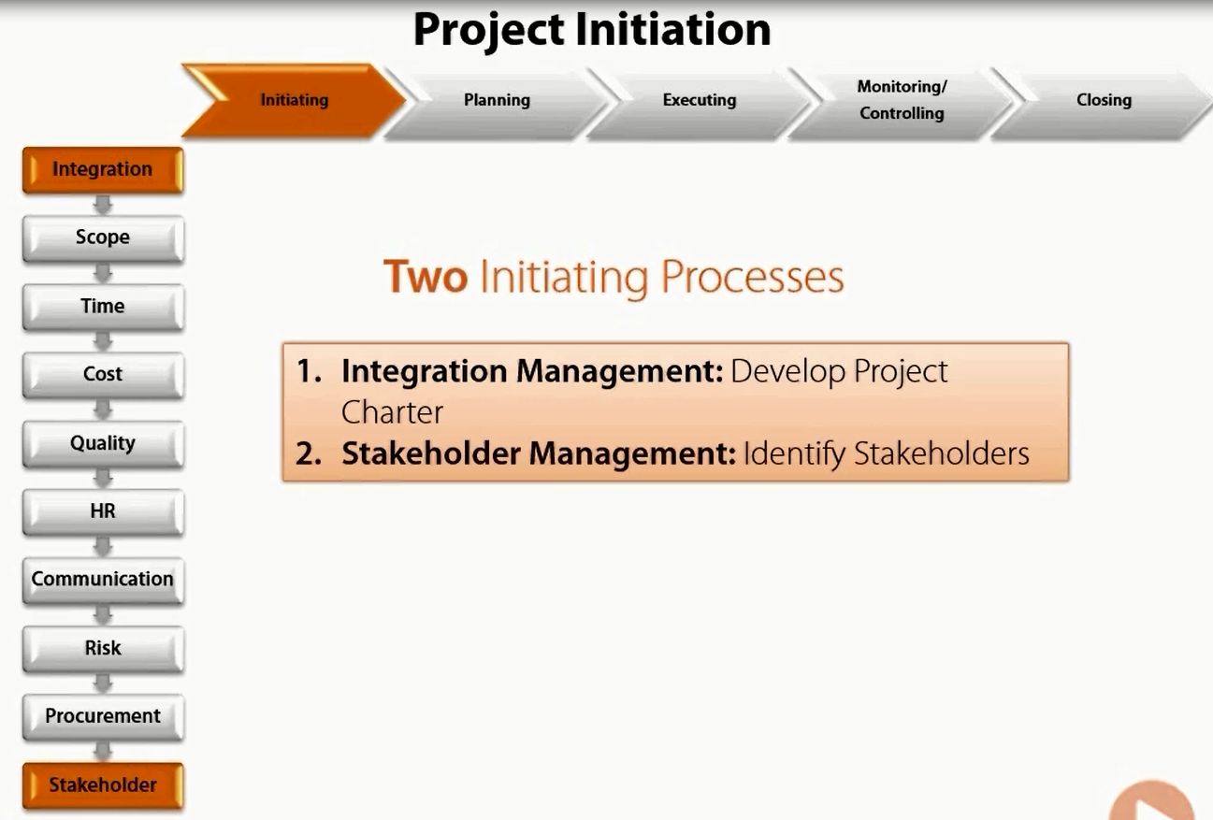

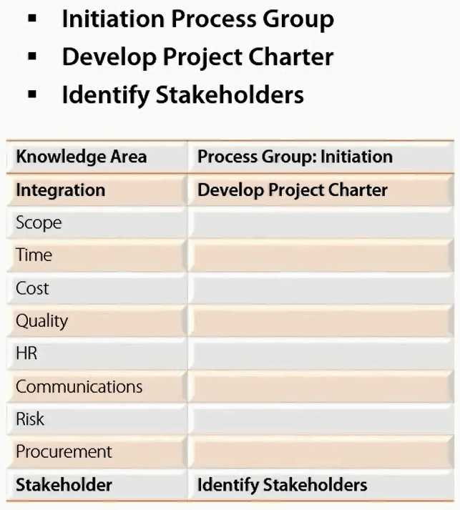

### Develop Project Charter

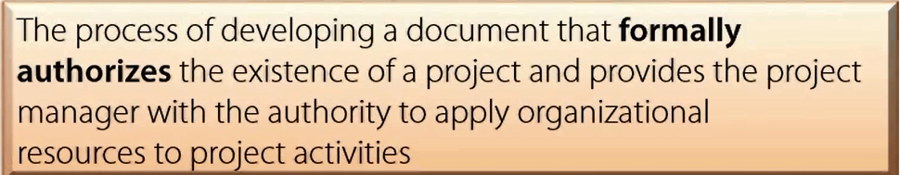

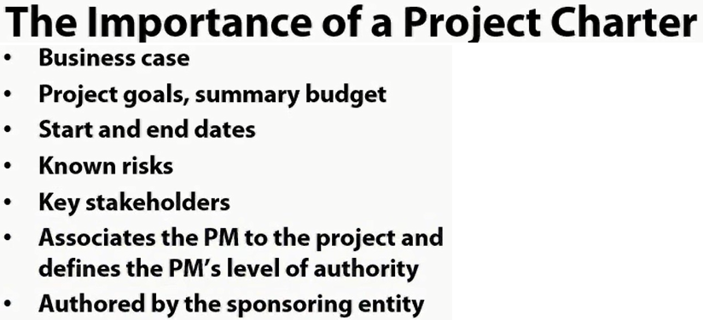

As per PMI Customer is EXTERNAL to your organization

**Choose Right Project**

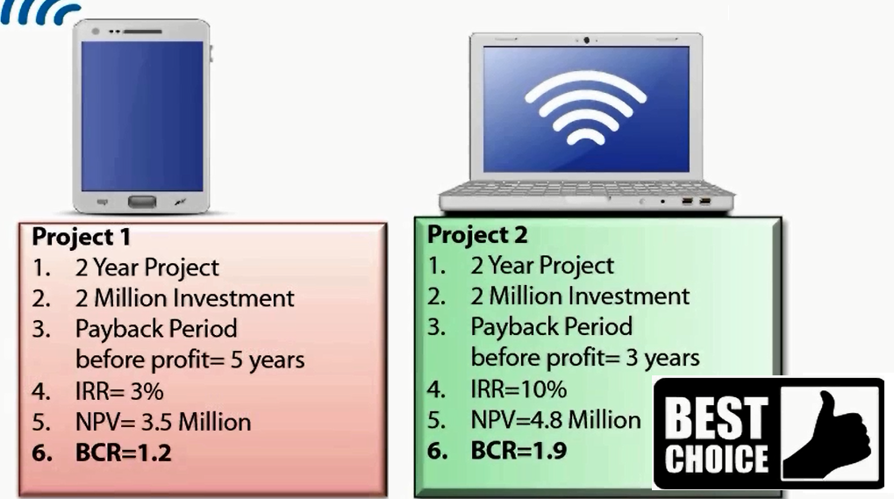

Payback Period





Internal Rate of Return (IIR)







Net Present Value





Benefit Cast Ratios (BCR)





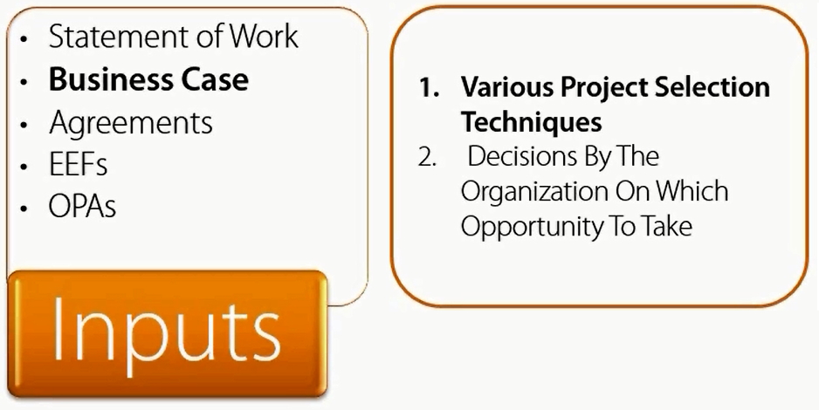

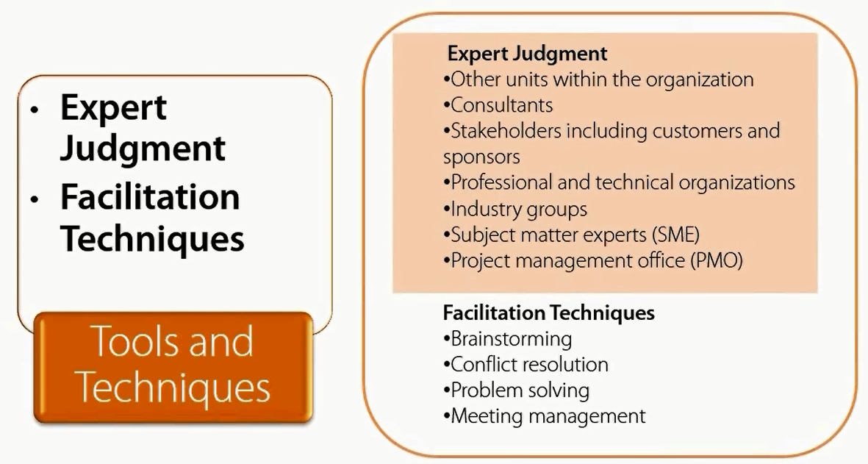

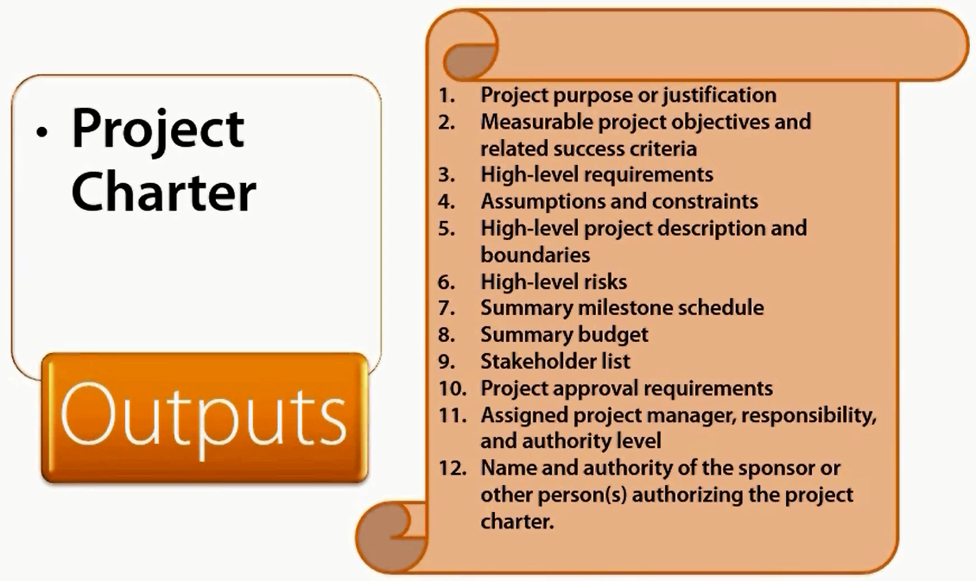

## Stakeholder Management

### Identify Stakeholders

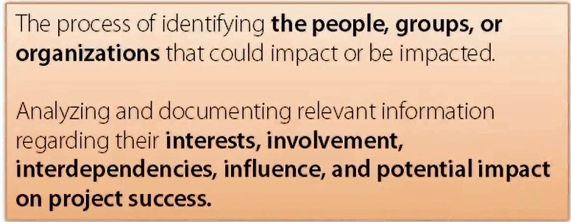

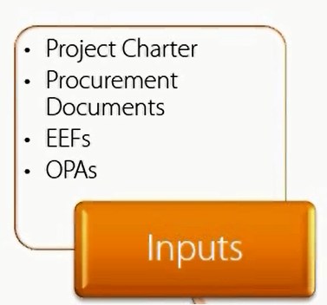

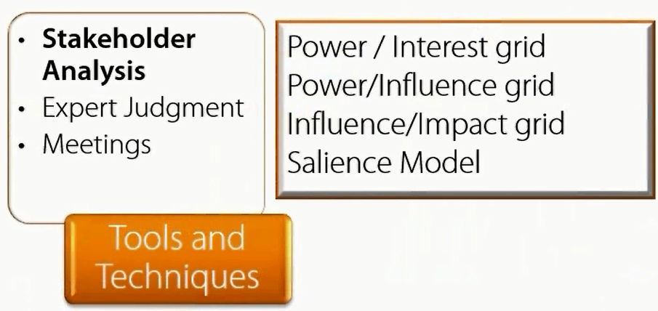

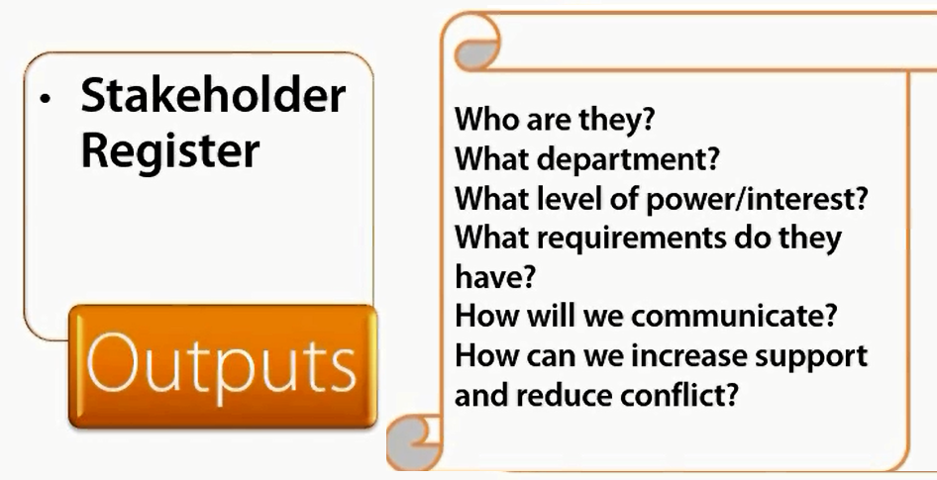

**Power Interest Grid**

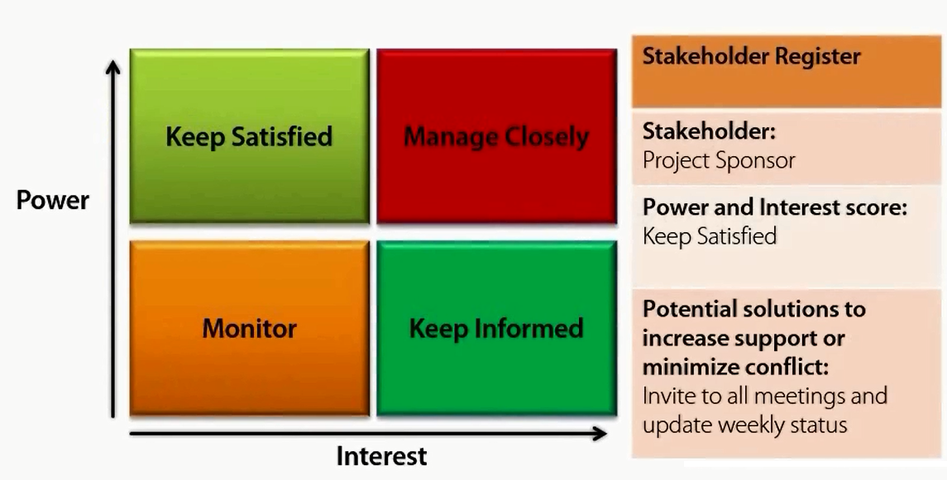

**Salience Model**

